CHARUSAT — CEUE203-OOP
PRACTICAL 1 .

 | Practical
P1.1 | Vending machine (VendingMachine.java, main in this file)  (a) Define an enum Coin with constants ONE, TWO, FIVE, TEN.  (b) In main, set a snack price of 15 and a running total of 0; create a Scanner.  (c) Loop: read a coin name, use a switch expression to convert the Coin to its value  (ONE→1, TWO→2, FIVE→5, TEN→10), add it to the total, and print the total so  far.  (d) Stop the loop once the total reaches 15 or more.  (e) Print the change to return (total − 15).  Expected output: TEN then FIVE prints “Paid. Change: 0”; TEN then TEN prints  “Paid. Change: 5”.
Code | import java.util.Scanner;  enum Coin { ONE, TWO, FIVE, TEN }  public class VendingMachine {  public static void main(String[] args) {  final int price = 15;  int total = 0;  try (Scanner sc = new Scanner(System.in)) {  while (total < price) {  System.out.print("Enter coin (ONE, TWO, FIVE, TEN): ");  Coin coin = Coin.valueOf(sc.next().toUpperCase());  int value = switch (coin) {  case ONE -> 1; case TWO -> 2; case FIVE -> 5; case TEN -> 10;  };  total += value;  System.out.println("Total so far: " + total);  }  System.out.println("Paid. Change: " + (total - price));  } catch (IllegalArgumentException e) {  System.out.println("Invalid coin name. Run again and enter a valid coin.");  }  }  }
Output | 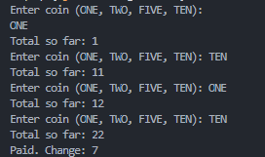

 | Practical
P1.2 | Toll booth (TollBooth.java, main in this file)  (a) Define a record Vehicle(String number, String type).  (b) In main, keep a running toll total and three counters (bike, car, truck).  (c) Loop until the user types “done” for the number: build a Vehicle, use a switch  expression on its type for the toll (bike→20, car→50, truck→150), add to the total,  and increment that type’s counter.  (d) After the loop, print the total toll and the type with the highest count.  Expected output: two cars + one bike → “Total toll: 120”, “Most frequent: car”.
Code | import java.util.Scanner;  public class TollBooth {  record Vehicle(String number, String type) {  }  public static void main(String[] args) {  Scanner sc = new Scanner(System.in);  int totalToll = 0;  int bike = 0, car = 0, truck = 0;  while (true) {  System.out.print("Enter vehicle number (or done): ");  String number = sc.nextLine();  if (number.equalsIgnoreCase("done")) {  break;  }  System.out.print("Enter vehicle type (bike/car/truck): ");  String type = sc.nextLine().toLowerCase();  Vehicle v = new Vehicle(number, type);  int toll = switch (v.type()) {  case "bike" -> 20;  case "car" -> 50;  case "truck" -> 150;  default -> -1;  };  if (toll == -1) {  System.out.println("Invalid vehicle type!");  continue;  }  totalToll += toll;  switch (v.type()) {  case "bike" -> bike++;  case "car" -> car++;  case "truck" -> truck++;  }  System.out.println("Toll: " + toll);  }  System.out.println("\nTotal Toll: " + totalToll);  if (bike >= car && bike >= truck) {  System.out.println("Highest Count: Bike");  } else if (car >= bike && car >= truck) {  System.out.println("Highest Count: Car");  } else {  System.out.println("Highest Count: Truck");  }  sc.close();  }  }
Output | 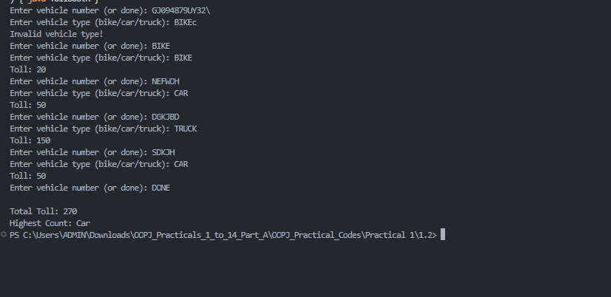

 | Practical
P1.3 | Rock-Paper-Scissors-Lizard-Spock (RPSLS.java)  (a) Define an enum Move with ROCK, PAPER, SCISSORS, LIZARD, SPOCK.  (b) Write winner(Move a, Move b) returning 1 if a beats b, -1 if b beats a, 0 for a tie —  use a switch expression listing what each move beats (Scissors cut Paper, Paper  covers Rock, Rock crushes Lizard, Lizard poisons Spock, Spock smashes Scissors,  and the five mirror cases).  (c) In main, play 5 rounds: pick a random computer Move, read the player’s Move, call  winner(), print the round result and keep score.  (d) After 5 rounds, print the overall winner.
Code | import java.util.Scanner;  import java.util.Random;  public class RPSLS {  enum Move {  ROCK, PAPER, SCISSORS, LIZARD, SPOCK  }  public static int winner(Move a, Move b) {  return switch (a) {  case ROCK -> switch (b) {  case SCISSORS, LIZARD -> 1;  case PAPER, SPOCK -> -1;  case ROCK -> 0;  };  case PAPER -> switch (b) {  case ROCK, SPOCK -> 1;  case SCISSORS, LIZARD -> -1;  case PAPER -> 0;  };  case SCISSORS -> switch (b) {  case PAPER, LIZARD -> 1;  case ROCK, SPOCK -> -1;  case SCISSORS -> 0;  };  case LIZARD -> switch (b) {  case PAPER, SPOCK -> 1;  case ROCK, SCISSORS -> -1;  case LIZARD -> 0;  };  case SPOCK -> switch (b) {  case ROCK, SCISSORS -> 1;  case PAPER, LIZARD -> -1;  case SPOCK -> 0;  };  };  }  public static void main(String[] args) {  Scanner sc = new Scanner(System.in);  Random random = new Random();  int playerScore = 0;  int computerScore = 0;  System.out.println("ROCK PAPER SCISSORS LIZARD SPOCK");  for (int i = 1; i <= 5; i++) {  System.out.println("\nRound " + i);  Move player;  while (true) {  System.out.print("Enter your move: ");  String input = sc.nextLine().trim().toUpperCase();  try {  player = Move.valueOf(input);  break;  } catch (IllegalArgumentException e) {  System.out.println("Invalid move! Try again.");  }  }  Move computer = Move.values()[  random.nextInt(Move.values().length)  ];  System.out.println("Your Move: " + player);  System.out.println("Computer Move: " + computer);  int result = winner(player, computer);  if (result == 1) {  System.out.println("You win this round!");  playerScore++;  } else if (result == -1) {  System.out.println("Computer wins this round!");  computerScore++;  } else {  System.out.println("It's a tie!");  }  System.out.println("Score: " + playerScore + " - " + computerScore);  }  System.out.println("\n===== FINAL RESULT =====");  if (playerScore > computerScore) {  System.out.println("You win " + playerScore + "–" + computerScore);  } else if (computerScore > playerScore) {  System.out.println("Computer wins " + computerScore + "–" + playerScore);  } else {  System.out.println("Overall Match Draw!");  }  sc.close();  }  }
Output | 

